PRE-DEFINED TABLE IN SAP (30-09-2021)

Every table has a unique name and consists of rows and columns. The number of columns in a table is fixed but can have any number of rows.

ABAP dictionary handles the DDL part of SQL in SAP. Go to ABAP dictionary (SE11) to create a SAP table. Enter the name of the table to be created and press enter.

**Step 1: –** Enter transaction code “SE11” in the SAP command field and press enter to continue.

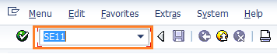

**Step 2: –** On the initial screen, select the database table option and enter the name of the database table that you want to be created. After updating name click on create button. Here we are creating ZTEST_EMP table.

* Database Table: ZTEST_EMP

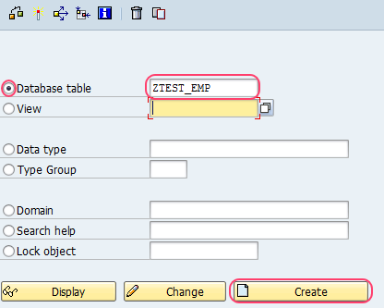

**Step 3:** – On the next screen, update the following data. By default, delivery and maintenance tab is selected.

1. **Short Description:** Update the short description of the database table.
2. **Delivery Class:** Update the delivery class from the list, you can get the list be clicking the search option (F4).
3. **DataBrowser/TableViewMaintain:** Select the display/maintenance allowed from the drop down list.

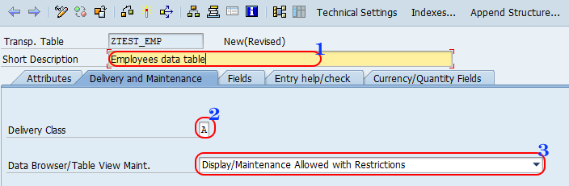

**Step 4: –** Select field tab and update the following data.

Enter the fields of the table and maintain the proper data elements for the table fields. You can use the standard data elements or you can create our own elements.

* **Field**: Update the field name in the field column (16 characters)
* **Key:** Select the key option if you want the field as table key.
* **Data Element:** Update the data element key from the list.

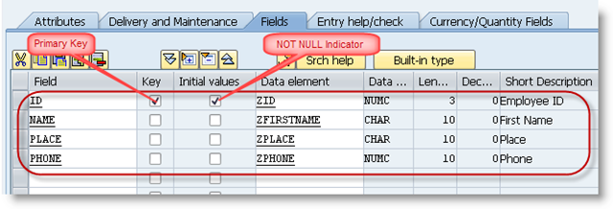

Click on save button to save the configured data. You get a message as ZTEST_EMP saved.

Maintain the primary key and press save. To maintain the technical attributes of table like tablespace, size etc. press the technical attributes button on application toolbar.

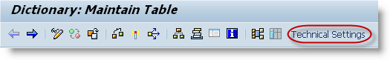

Enter Data class, size category and save.

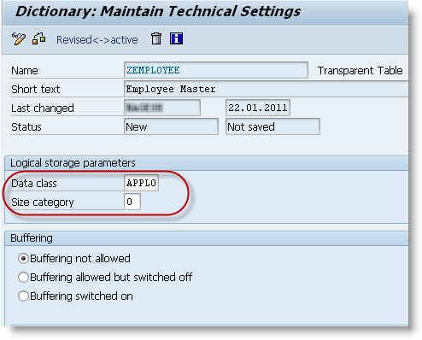

Now press back, save and activate the table.